C PROGRAMMING TO REVERSE A GIVEN STRING

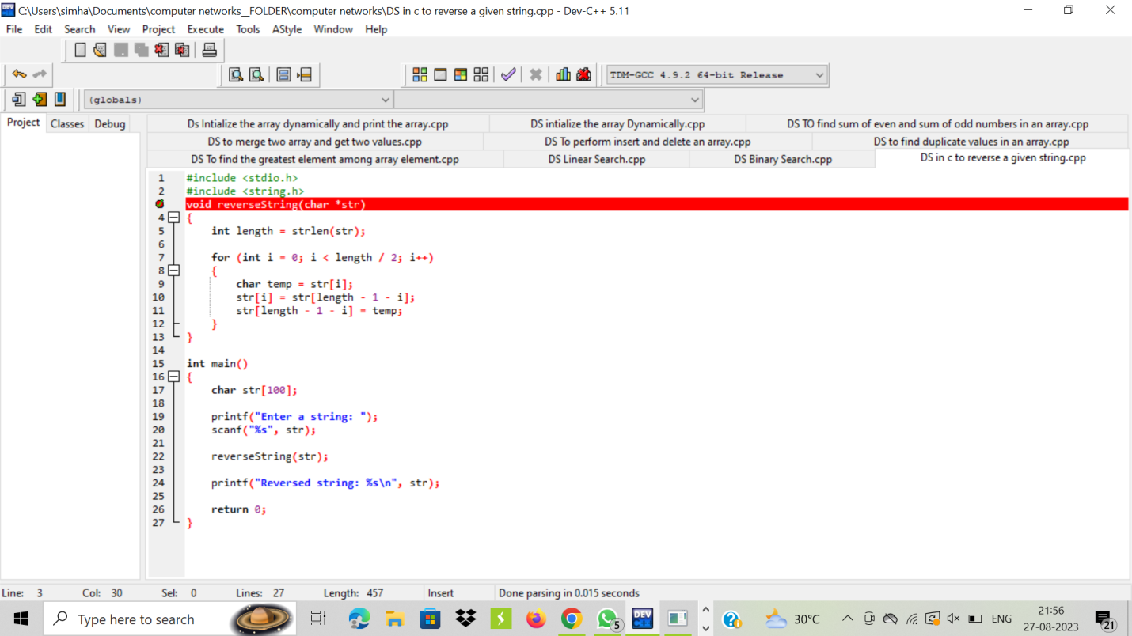

OUTPUT:

